|  |  |
| --- | --- |
| [P1-1] [User can create an account with invalid first name](https://projectqqqqqqqqqqqq.atlassian.net/browse/P1-1) Created: 02/Jan/24  Updated: 02/Jan/24 | |
| **Status:** | To Do |
| **Project:** | [p1](https://projectqqqqqqqqqqqq.atlassian.net/secure/BrowseProject.jspa?id=10000) |
| **Components:** | None |
| **Affects versions:** | None |
| **Fix versions:** | None |

|  |  |  |  |
| --- | --- | --- | --- |
| **Type:** | Bug | **Priority:** | Medium |
| **Reporter:** | [Md. Mohaimenur Rahman](https://projectqqqqqqqqqqqq.atlassian.net/secure/ViewProfile.jspa?accountId=712020%3A1dbf8346-f0a2-4d41-aac2-85251256f810) | **Assignee:** | [Md. Mohaimenur Rahman](https://projectqqqqqqqqqqqq.atlassian.net/secure/ViewProfile.jspa?accountId=712020%3A1dbf8346-f0a2-4d41-aac2-85251256f810) |
| **Resolution:** | Unresolved | **Votes:** | 0 |
| **Labels:** | web | | |
| **Remaining Estimate:** | Not Specified | | |
| **Time Spent:** | Not Specified | | |
| **Original estimate:** | Not Specified | | |

|  |  |
| --- | --- |
| **Attachments:** | 1.png     2.png     4.png |
| **Rank:** | 0|i0001r: |
| **Sprint:** |  |

|  |  |
| --- | --- |
| **Description** |  |

|  |
| --- |
| **URL:** <https://www.aarong.com/>  **STEPS:**   1. Click on my account 2. Click sign up now 3. Enter invalid first name 4. Fill the others required boxes with valid data 5. Click submit   **Expected Result:**  User should not able to create an account  **Actual Result:**  User can create an account  **Screenshot:** |

Generated at Tue Jan 02 19:48:38 UTC 2024 by Md. Mohaimenur Rahman using Jira 1001.0.0-SNAPSHOT#100244-sha1:831e4f792b0ed22295f607f13ef9ef34aa4e1dcf.

**Jira Screenshot**

**To-Do**

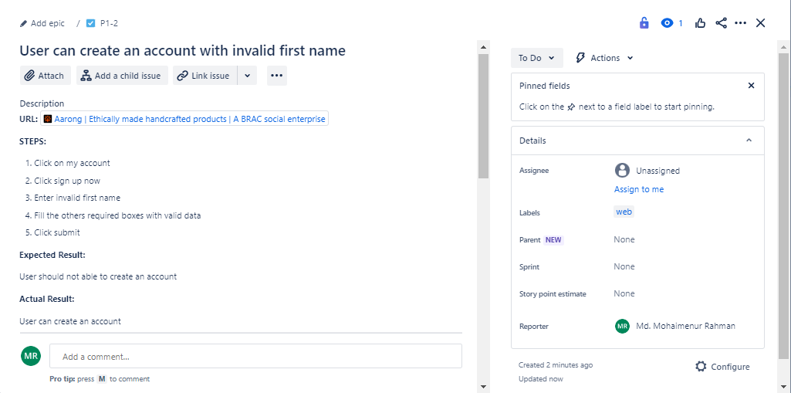

**In Progress**

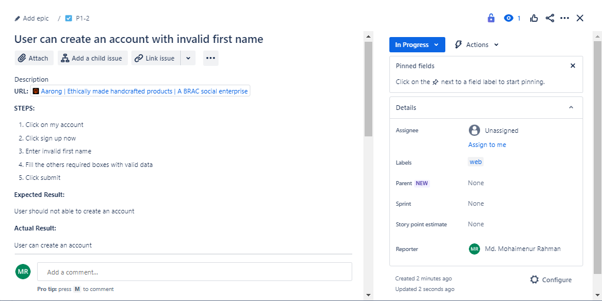

**Done**

